CIS Project screen shots

# Home Page

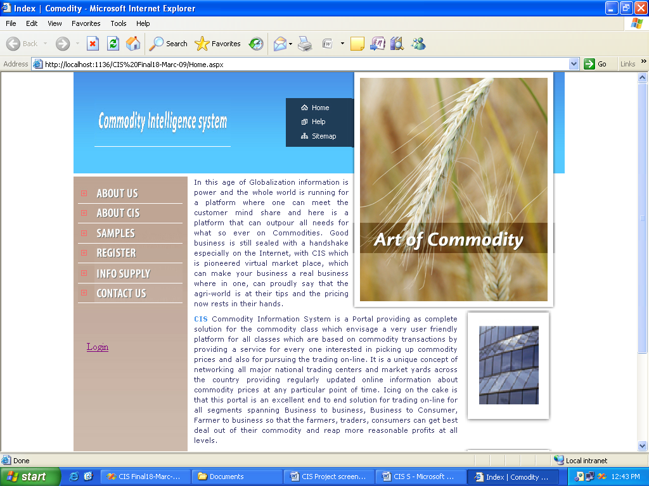

**Customer Registration**

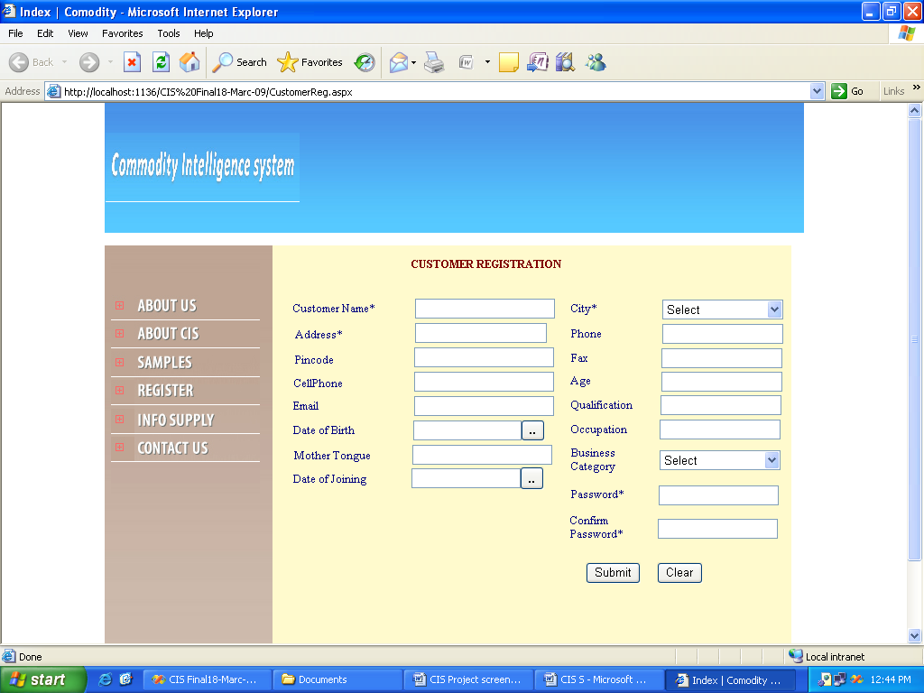

**INFO SUPPLIER REGISTRATION SCREEN**

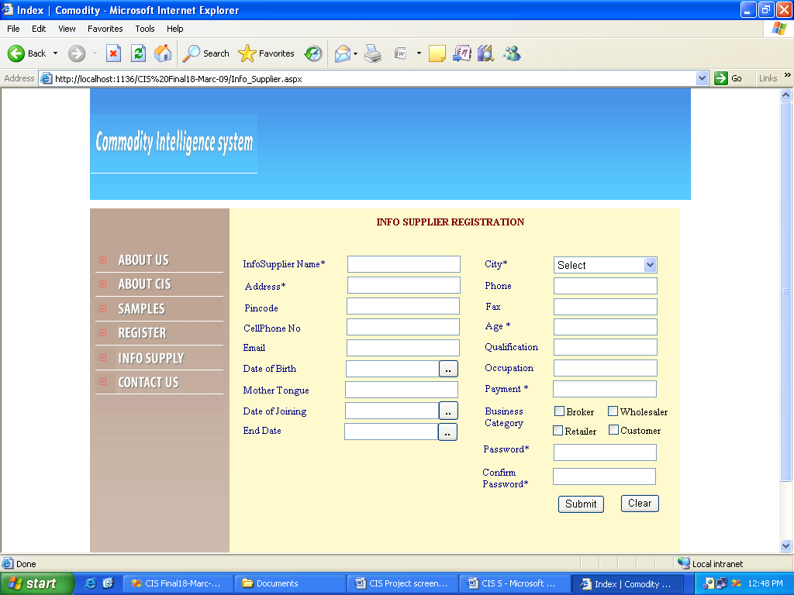

**LOGIN SCREEN**

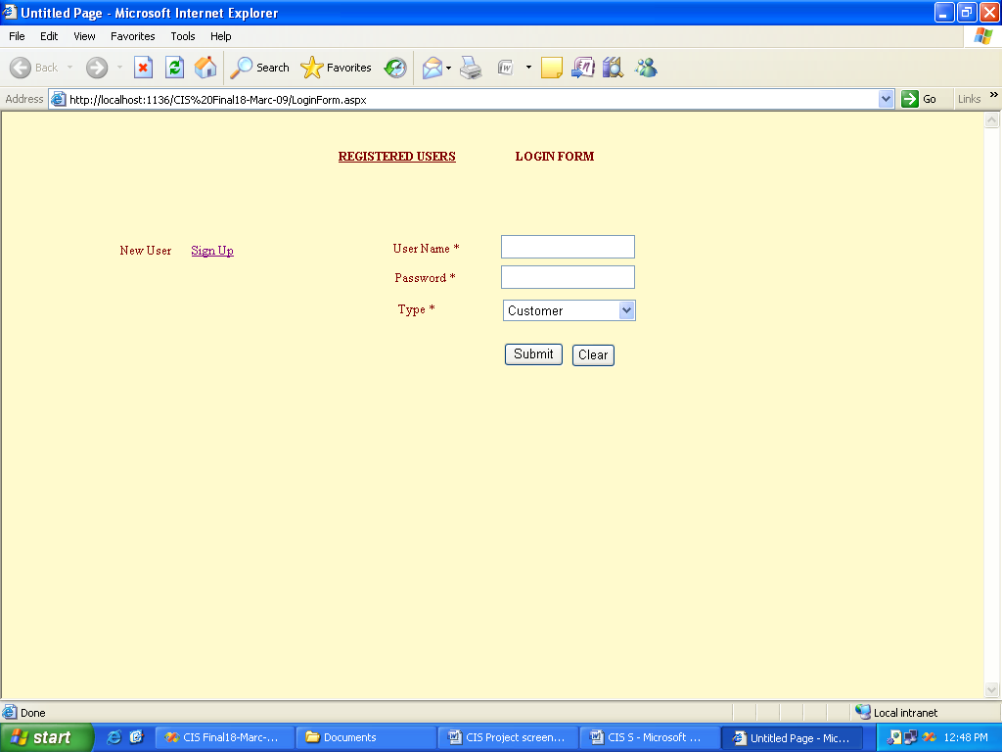

**ADMIN HOME PAGE**

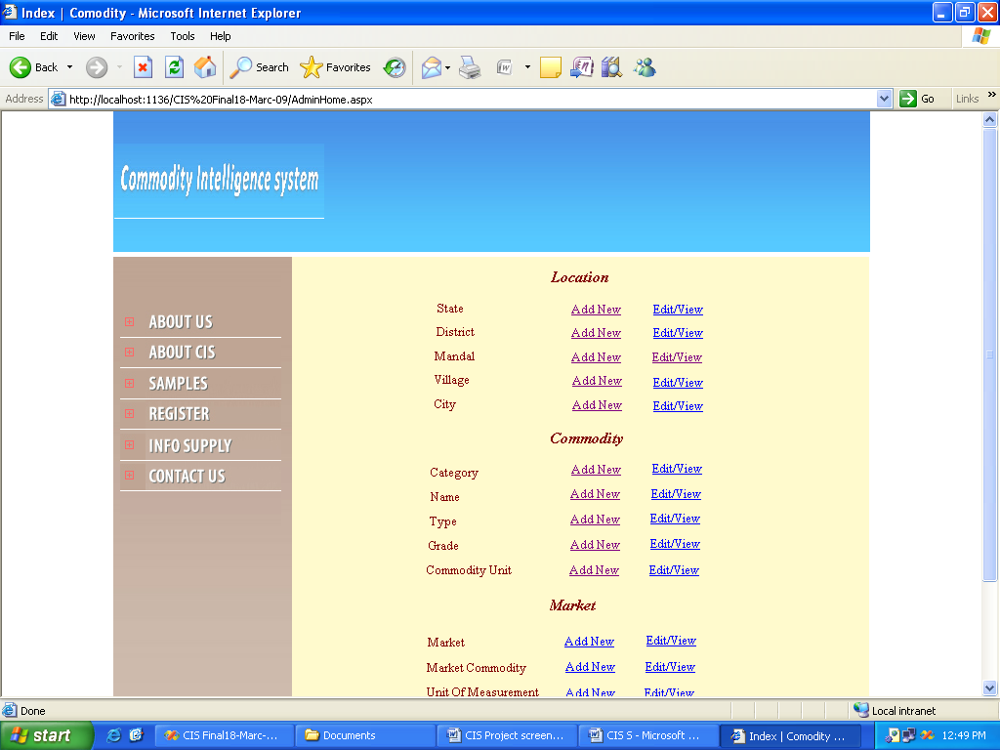

**ADMIN HOME PAGE**

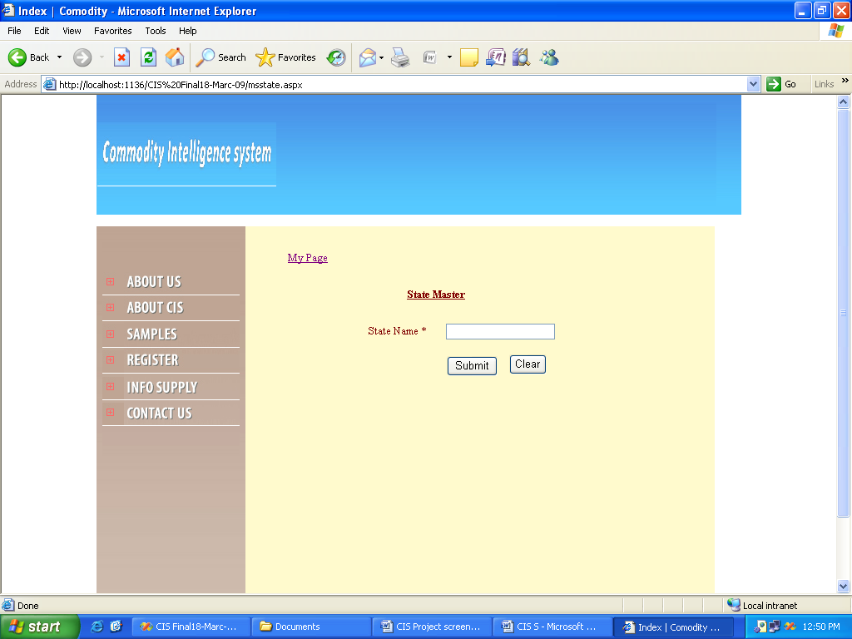

**LOCATION ---- MADAL ENTRY SCREEN**

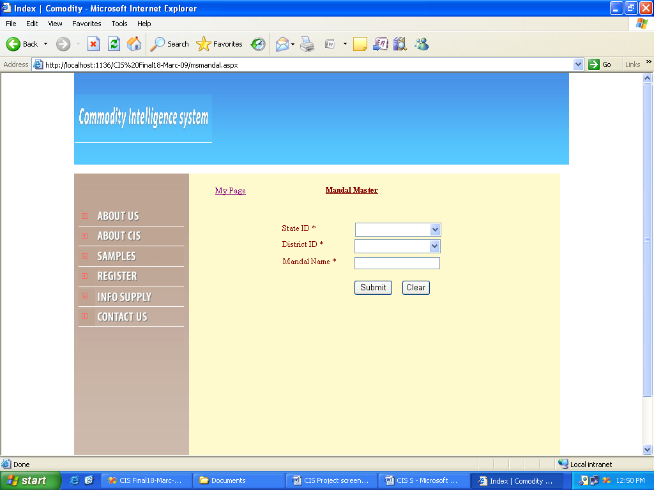

**LOCATION – VILLAGE ENTRY SCREEN**

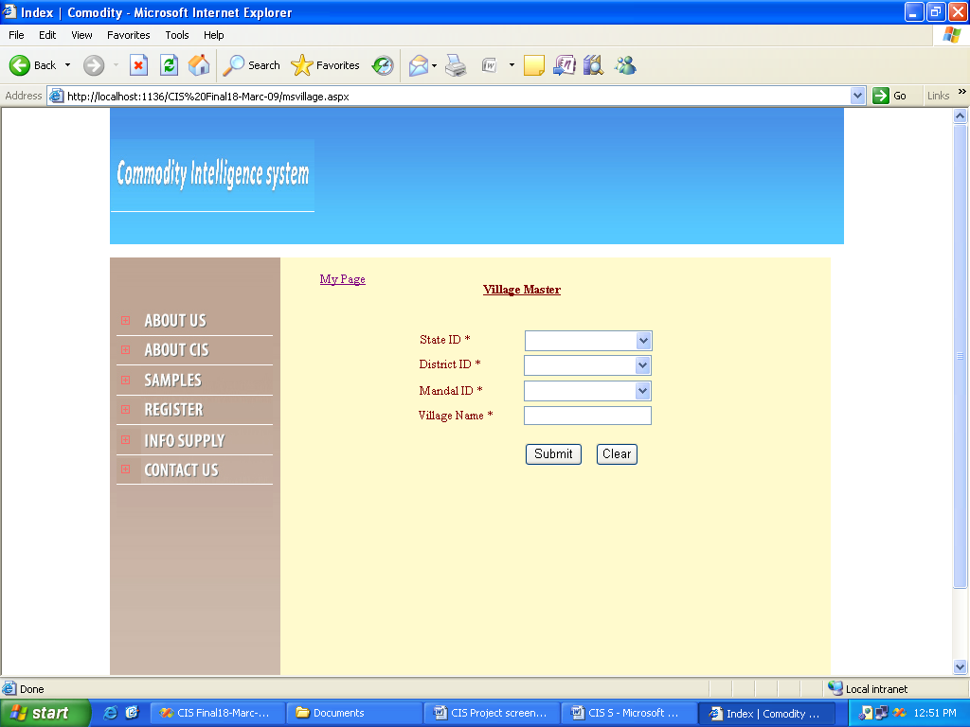

**COMMODITY – CATEGORY ENTRY SCREEN**

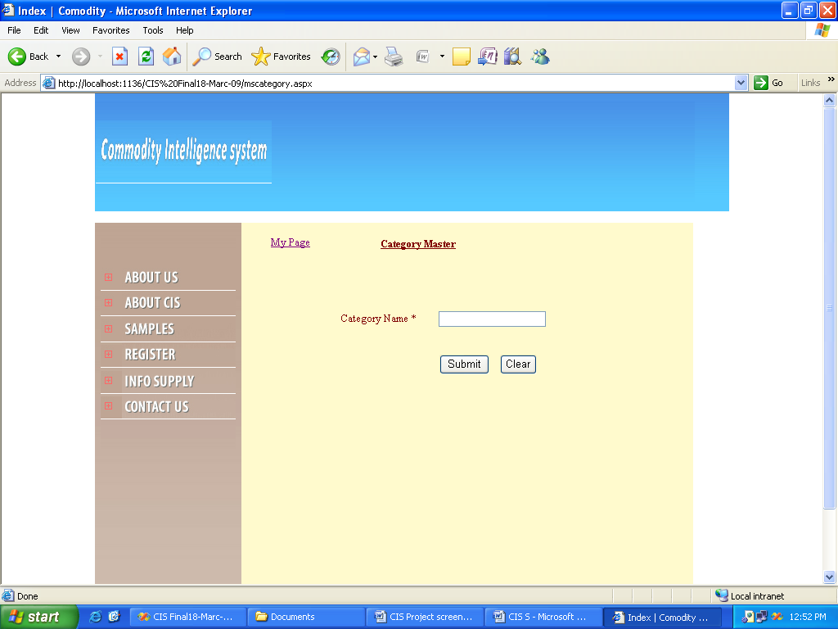

**COMMODITY – TYPE ENTRY SCREEN**

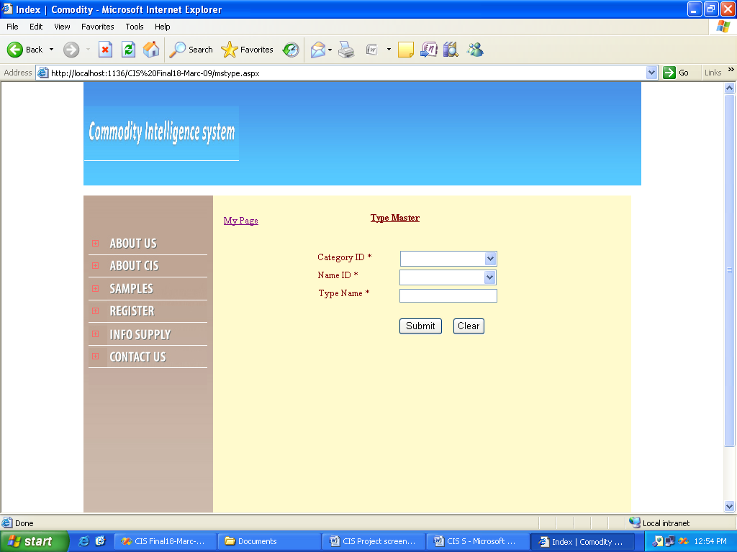

**COMMODITY – GRADE ENTRY SCREEN**

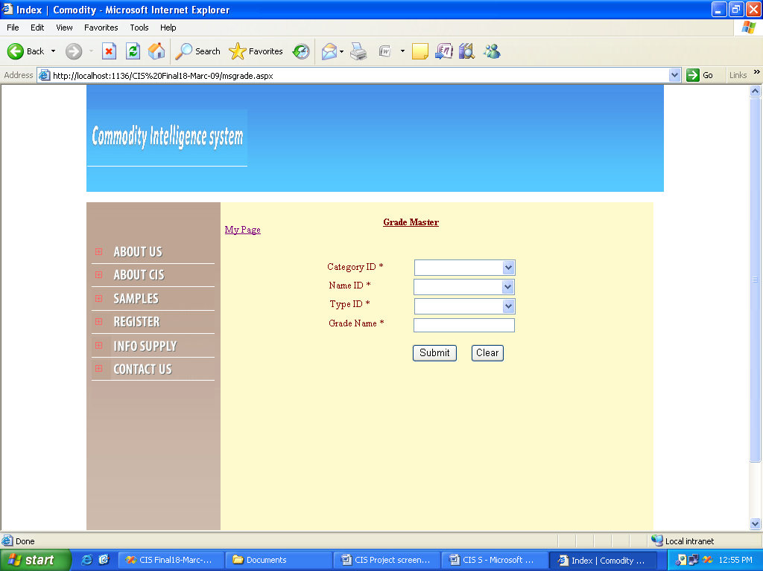

**COMMODITY – UNIT ENTRY SCREEN**

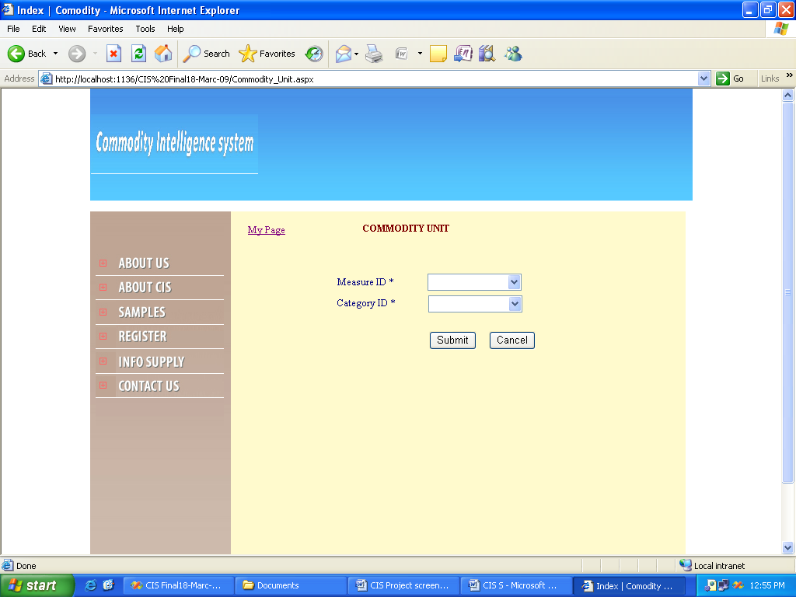

# MARKET ENTRY SCREEN

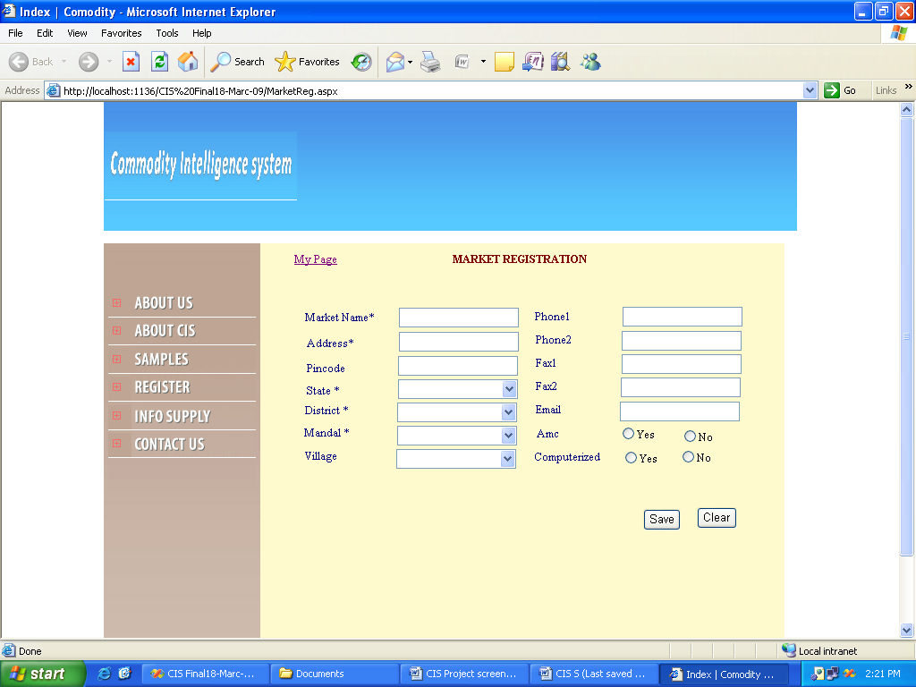

**MARKET COMMODITY**

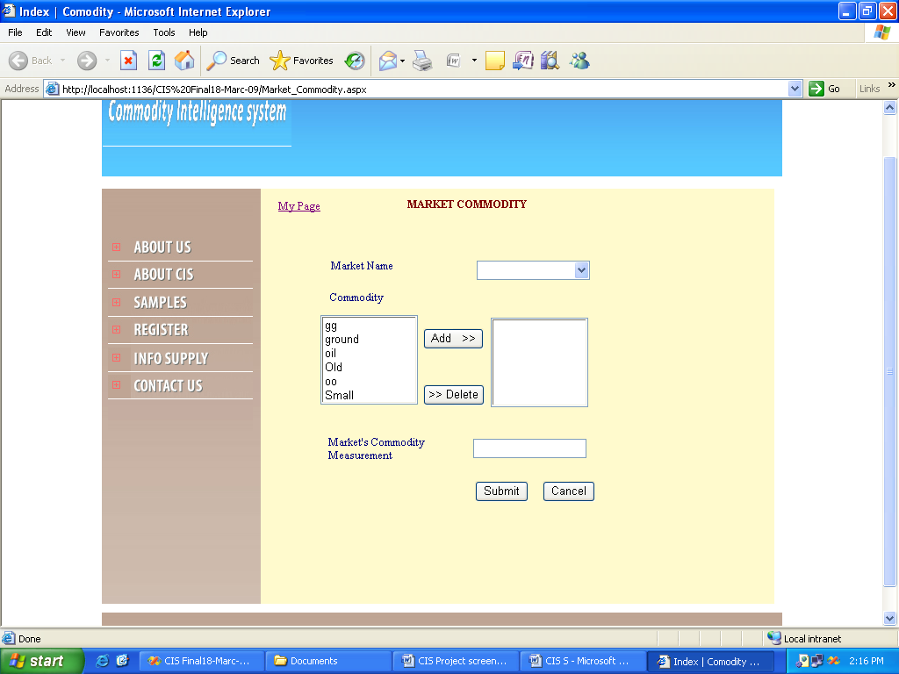

**UNIT OF MEASUREMENT ENTRY SCREEN**

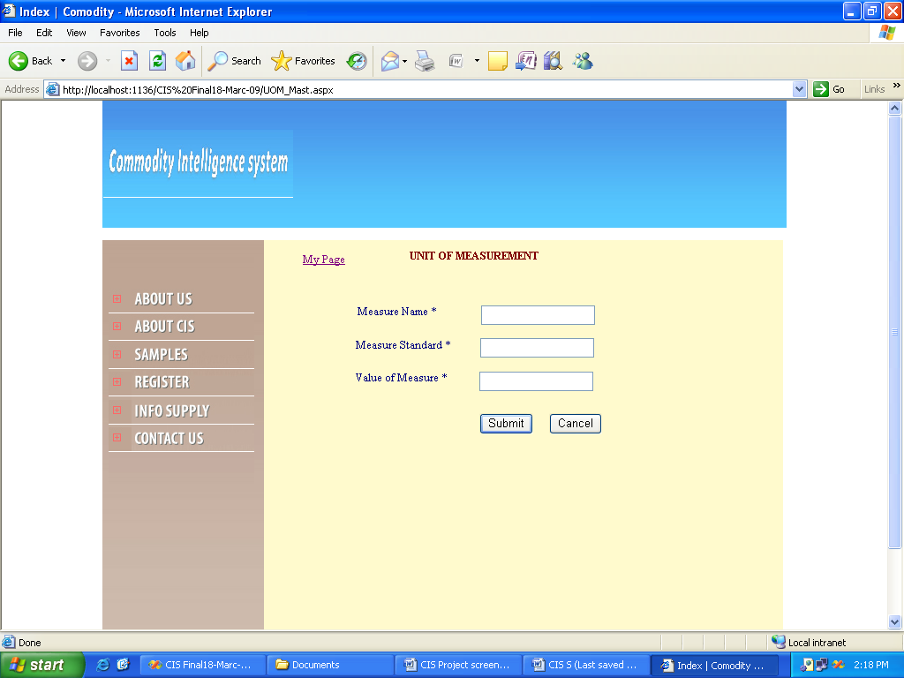

**CIS REPORTS**

